**Experience Meet up (structure)**

<http://erni-consultants.com/experience-meet-up> (an example)

1. FORM

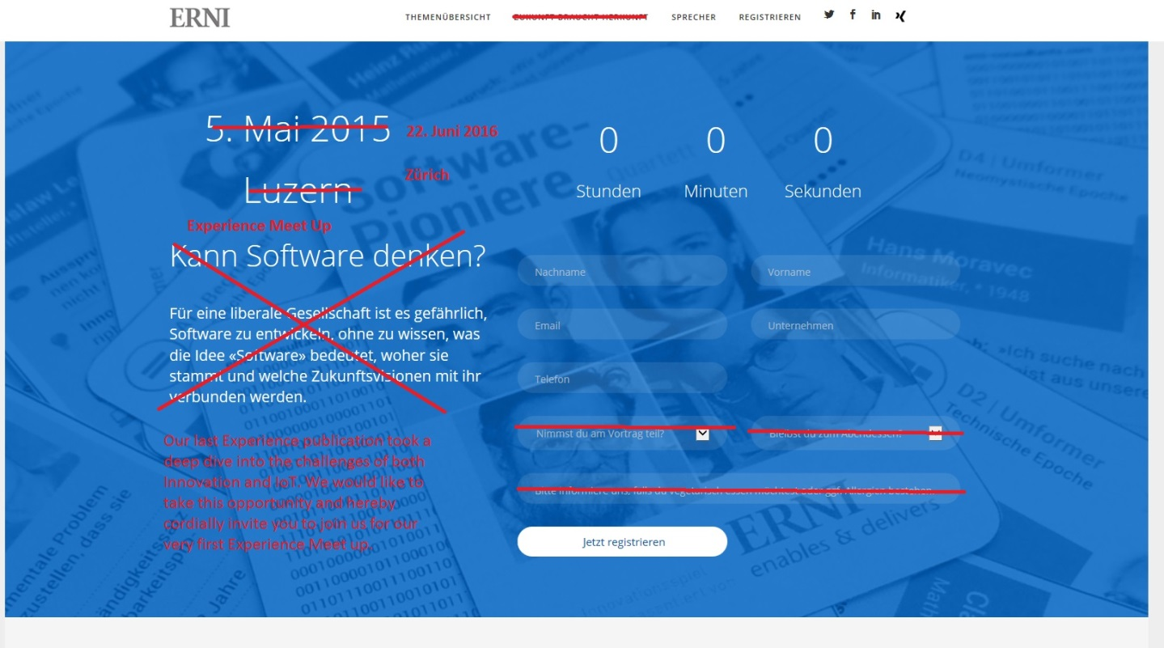

22. Juni/June 2016

Zürich

Experience Meet up

Our last Experience publication took a deep dive into the challenges of both Innovation and IoT. We would like to take this opportunity and hereby cordially invite you to join us for our very first Experience Meet up.

Background: Picture from the invitation (we will buy it in higher resolution).



This you can completely remove:

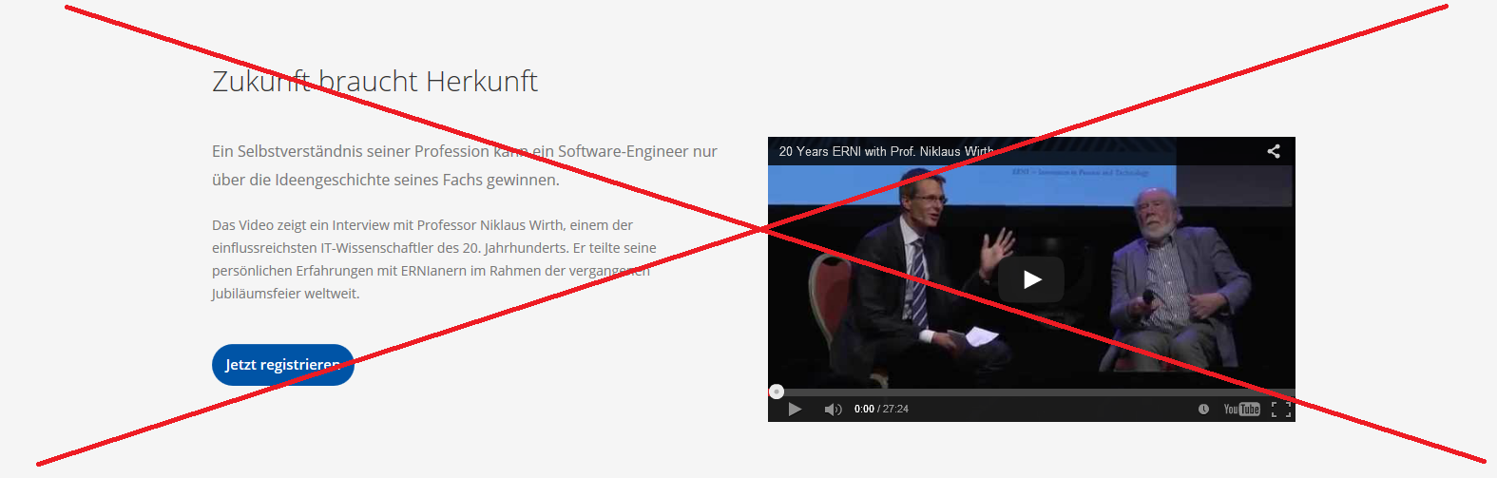

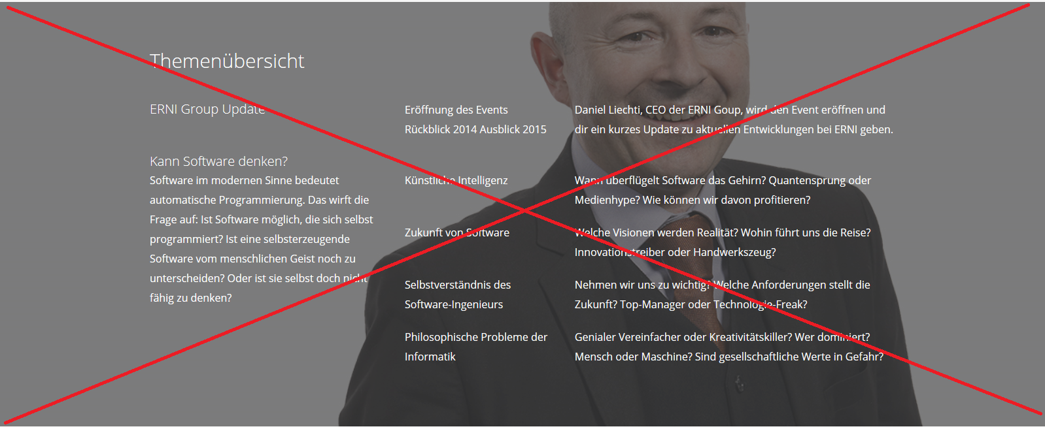

1. SPRECHER/EVENT SPEAKERS

**Strategic Innovation and Digital Everything!**By Jazz Kang



Jazz Kang, Principal Consultant at ERNI Consulting AG, will explain why Innovation has become such a trending topic, how it challenges industries today and what processes and methods many companies are adapting to meet these challenges. Jazz will also highlight the methods than can help drive companies towards Digitization and Industry 4.0 initiatives. In this session we will also be looking at how new ideas fit into traditional models.

**Innovation and IoT @Hapa AG**by Beat Rupp



Beat Rupp, CEO of Hapa AG, will be bringing us live industry experience of how to apply innovation to his business through the power of IoT. As well as the technology, Beat will focus in his presentation on his organizations own journey in adapting to the challenges of innovation. Using fast iterative development processes and adopting the philosophy of taking “many small bets” to find the right path amongst the many choices that the industry is presented with.

1. AGENDA & EVENT LOCATION

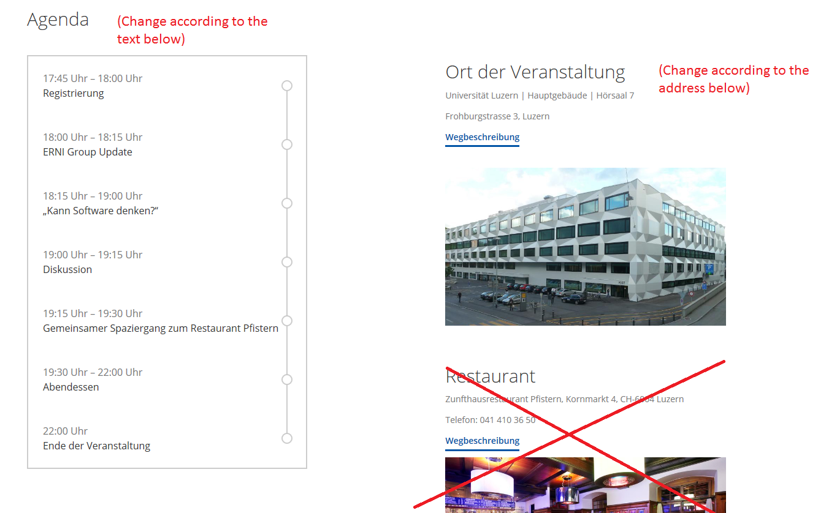

**Agenda:**

17.15-17.30 Welcome Apéro & Registration  
17.30-17.40 Introduction by Martin Graf  
17:40-18:10 Strategic Innovation and Digital Everything! by Jazz Kang  
18:10-18:40 Innovation and IoT @Hapa AG by Beat Rupp  
18.40-19.00 Networking

**Ort der Veranstaltung/Event Location:**

Kameha Grand Zürich

Dufaux-Strasse 1/Corner Thurgauerstrasse

CH-8152 Glattpark/Zürich, Schweiz

Tel: [+41 44 525 5000](tel:+41%2044%20525%205000)

Email: [zurich@kameha.com](mailto:zurich@kameha.com?subject=Anfrage%20via%20Website)

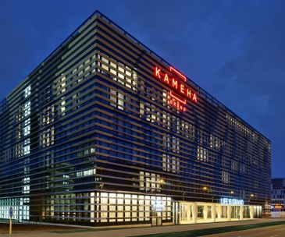

This you can again completely remove, just keep the map:

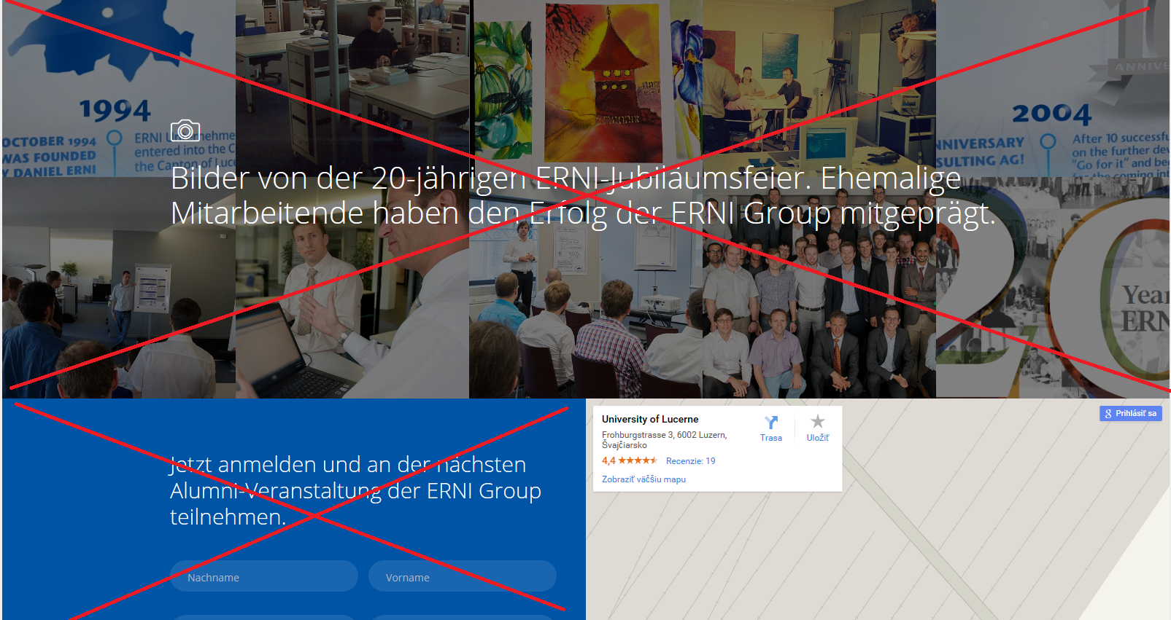

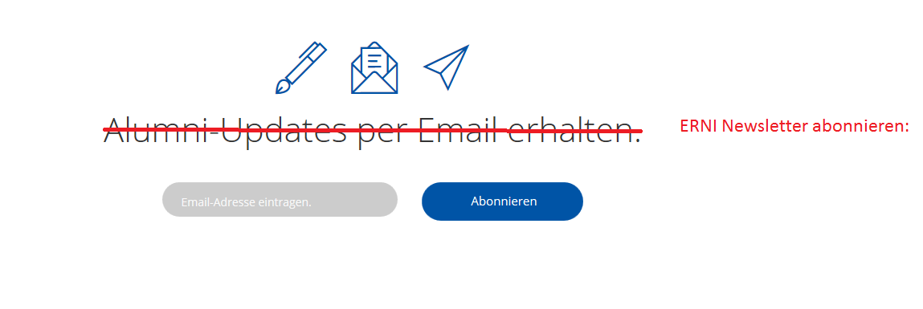

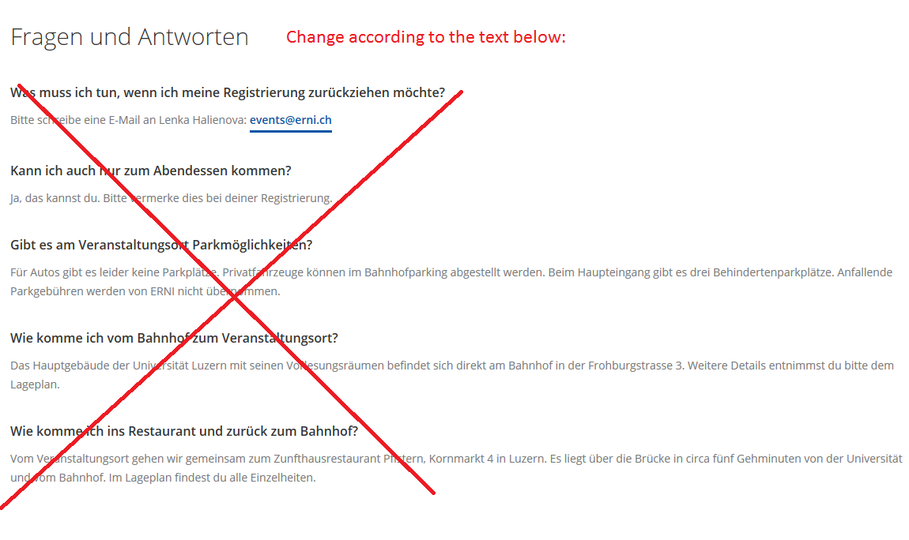

**Wichtig/Important:**

* Registration deadline is **May 31, 2016**.
* In case of any questions or regarding cancelation, please contact [events@erni.ch](mailto:events@erni.ch)
* If your corporate policy prohibits you to accept gifts, we will invoice you CHF 65.- for the cost of a ticket.